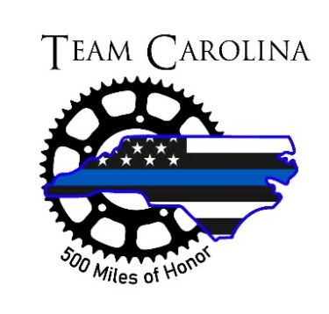
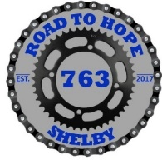


For Immediate Release

Law Enforcement Officers to Cycle through NC to Honor Fallen Officers
Kings Mountain – On Monday, May 5th, more than 60 law enforcement officers representing 20 local, state, and federal law enforcement agencies from North Carolina, and Virginia will start a cycling journey that will eventually end in Washington, D.C. The trip is in honor of all officers that perish in the line of duty.
The officers will pedal more than 280 miles across NC, starting in Shelby, NC and arriving in Raleigh, NC on May 7th. This year Kings Mountain Police Department will have 4 members join Team Shelby who will team up with Team Raleigh and Team Greenville in this endeavor to form Team Carolina.
This year Team Carolina will for the first time cycle through the western regions of NC stopping at agencies along the way that have lost an officer in the line of duty. They will hold a short End of Watch Ceremony at each agency and place a wreath in honor of their lost heroes. Agencies that will be honored include: Shelby Police Department, Cleveland County Sheriff’s Office and surrounding agencies, Kings Mountain Police Department, Gaston County Sheriff’s Office and surrounding agencies, Mount Holly Police Department, Charlotte-Mecklenburg Police Department, FBI, Concord Police Department, Kannapolis Police Department, Rowan County Sheriff’s Office and surrounding agencies, Lexington Police Department, Winston-Salem Police Department, Kernersville Police Department, Greensboro Police Department, Gibsonville Police Department, Alamance County Sheriff’s Office and surrounding agencies, Durham County Sheriff’s Office and surrounding agencies, Durham County Police Department, Raleigh Police Department, Wake County Sheriff’s Office, and North Carolina State Highway Patrol.
Team Carolina will arrive back in Raleigh on May 7th. Team Shelby will than travel to Cumberland Maryland to join other officers with the Road to Hope Ride organized by the Maryland Division of Law Enforcement United (LEU). LEU donates funds raised from this ride to support Concerns of Police Survivors (COPS) Kids Summer Camp, to help maintain the Officer Down Memorial Page (ODMP), and other charities supporting law enforcement and their families. The LEU group will cycle about 230 miles from Cumberland, MD to Washington DC over 3 days, again stopping and honoring fallen officers along the way.
Upon arriving in Washington DC, the riders will attend the 37th Annual Candlelight Vigil at the National Mall. The vigil is among several activities that will mark National Police Week and recognize the ultimate sacrifice made by fallen officers.
You can follow Team Shelby’s journey on their Facebook account at
https://www.facebook.com/RoadToHope

